EXP 9
ANALYSIS OF PHOTODETECTOR NOISE AND SNR USING MATLAB/SCILAB

OBJECTIVES

1. Analyze the key noise sources in an optical photodetector, namely shot noise, dark current noise and thermal (receiver) noise.
2. Compute the individual and total noise current variances (σ²) across a range of input optical powers.
3. Evaluate the Signal-to-Noise Ratio (SNR) and observe its scaling in the thermal noise-limited and shot-noise-limited regimes.
4. Calculate the Minimum Detectable Optical Power (Pmin) at SNR = 1 (0 dB).
5. Simulate and visualize photodetector noise and SNR curves using MATLAB.

SOFTWARE REQUIRED

• MATLAB (or GNU Octave / Scilab)

EXPERIMENT PROCEDURE:
1. Open MATLAB and create a new script file named photodetector_noise.m.
2. Define the constants (q, kB, h, c) and the input parameters given in the table below.
3. Create the input power array from −60 dBm to 0 dBm in 0.1 dBm .
4. Compute the responsivity R = ηqλ/hc and the signal current Ip = R·Pin.
5. Compute the shot noise 2q·Ip·B, dark noise 2q·Id·B and thermal noise 4kB·T·B·Fn/RL variances, and their sum.
6. Compute SNR = Ip²/σ²total and SNR(dB) = 10 log10(SNR).
7. Solve R²Pmin² − 2qBR·Pmin − (σ²dark + σ²th) = 0 for Pmin (SNR = 1) and convert it to dBm.
8. Plot the noise variances (log–log) and the SNR against input power with a 0 dB reference line.
9. Run the script, record the values and compare the results at different input powers.

PROGRAM
clc; clear;
close all;
q = 1.602e-19; kB = 1.381e-23; h = 6.626e-34; c = 2.998e8;
lambda = 1550e-9;
eta = 0.85;
Id = 5e-9;
T = 300;
RL = 50;
Fn = 2;
B = 1e9;
Pdbm = -60:0.1:0;
P = 10.^((Pdbm-30)/10); % input power (W)
%% 2. Responsivity and signal current
R = eta*q*lambda/(h*c);
Ip = R*P;
var_shot = 2*q*Ip*B;
var_dark = 2*q*Id*B;
var_th = 4*kB*T*B*Fn/RL;
var_tot = var_shot + var_dark + var_th;
SNR_dB = 10*log10(Ip.^2 ./ var_tot);
%% 4. Minimum detectable power (SNR = 1)
a = R^2; b = -2*q*B*R; cc = -(var_dark + var_th);
Pmin = (-b + sqrt(b^2 - 4*a*cc))/(2*a);
PmindBm = 10*log10(Pmin) + 30;
[~,k] = min(abs(Pdbm+30)); % index of -30 dBm
fprintf('Responsivity R = %.4f A/W\n', R);
fprintf('Thermal variance = %.3e A^2\n', var_th);
fprintf('Dark variance = %.3e A^2\n', var_dark);
fprintf('Shot variance(-30) = %.3e A^2\n', var_shot(k));
fprintf('SNR at -30 dBm = %.2f dB\n', SNR_dB(k));
fprintf('Pmin (SNR = 1) = %.2f dBm (%.1f nW)\n', PmindBm, Pmin*1e9);
%% 6. Plots
subplot(2,1,1);
loglog(P, var_th*ones(size(P)), P, var_dark*ones(size(P)), P, var_shot, P, var_tot);
grid on; xlabel('P_{in} (W)'); ylabel('Noise variance (A^2)');
legend('Thermal','Dark','Shot','Total','Location','best');
subplot(2,1,2);
plot(Pdbm, SNR_dB); hold on; plot([-60 0],[0 0],'r--'); plot([PmindBm PmindBm],[-60
70],'k:');
grid on; xlabel('P_{in} (dBm)'); ylabel('SNR (dB)');

OUTPUT
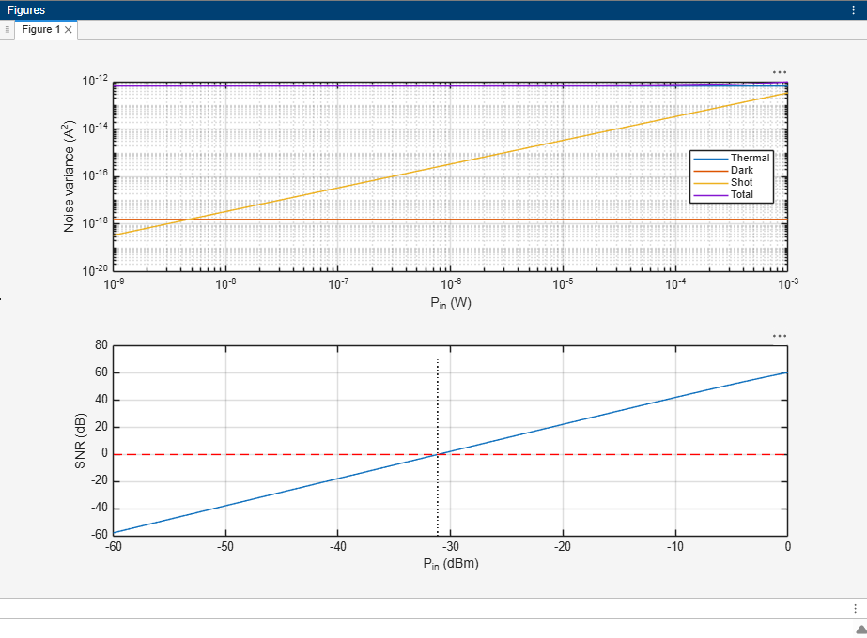

REFLECTION
This experiment helped me understand the different noise sources in photodetectors, including shot noise, dark current noise, and thermal noise. I learned to calculate the signal-to-noise ratio (SNR) using MATLAB/SCILAB. The simulation helped me analyse how noise affects signal quality and detector performance. This experiment improved my understanding of photodetector noise analysis and signal processing.
LABORATORY PERFORMANCE ASSESSMENT RUBRIC
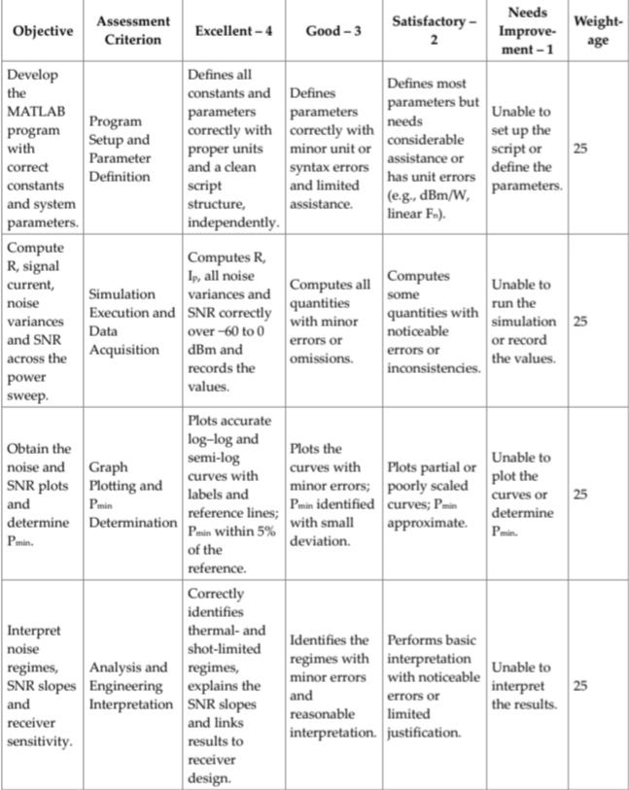

RESULT
The study shows how input optical power affects noise and SNR in a PIN photodetector receiver. Performance depends on the power level:
• Low power: thermal noise dominates, giving negative SNR and no reliable detection (below Pmin ≈ −31.16 dBm).
• Moderate power: the signal rises above the thermal noise and the SNR increases at 20 dB/decade. • High power: SNR becomes large and shot noise grows linearly, approaching the thermal level near +2.9 dBm.
These results help in estimating the receiver sensitivity and in designing low-noise optical receivers.

